Rossmoyne Senior High School

Semester One Examination, 2014

Question/Answer Booklet

MATHEMATICS 2C
SOLUTIONS

Section Two:

Calculator-assumed

Student Number: In figures

In words

Your name

Time allowed for this section
Reading time before commencing work: ten minutes
Working time for this section: one hundred minutes

Materials required/recommended for this section

To be provided by the supervisor
This Question/Answer Booklet
Formula Sheet (retained from Section One)

To be provided by the candidate
Standard items: pens, pencils, pencil sharpener, eraser, correction fluid/tape, ruler, highlighters

Special items: drawing instruments, templates, notes on two unfolded sheets of A4 paper, and up to three calculators satisfying the conditions set by the Curriculum Council for this examination.

Important note to candidates

No other items may be used in this section of the examination. It is your responsibility to ensure that you do not have any unauthorised notes or other items of a non-personal nature in the examination room. If you have any unauthorised material with you, hand it to the supervisor before reading any further.

Structure of this paper

Section | Number of questions available | Number of questions to be answered | Working time (minutes) | Marks available | Percentage of exam
Section One:  Calculator-free | 6 | 6 | 50 | 50 | 33⅓
Section Two:  Calculator-assumed | 12 | 12 | 100 | 100 | 66⅔
 |  |  | Total | 150 | 100

Instructions to candidates

- The rules for the conduct of Western Australian external examinations are detailed in the Year 12 Information Handbook 2013. Sitting this examination implies that you agree to abide by these rules.

- Write your answers in the spaces provided in this Question/Answer Booklet. Spare pages are included at the end of this booklet. They can be used for planning your responses and/or as additional space if required to continue an answer.
- Planning: If you use the spare pages for planning, indicate this clearly at the top of the page.
- Continuing an answer: If you need to use the space to continue an answer, indicate in the original answer space where the answer is continued, i.e. give the page number. Fill in the number of the question(s) that you are continuing to answer at the top of the page.

- Show all your working clearly. Your working should be in sufficient detail to allow your answers to be checked readily and for marks to be awarded for reasoning. Incorrect answers given without supporting reasoning cannot be allocated any marks. For any question or part question worth more than two marks, valid working or justification is required to receive full marks. If you repeat an answer to any question, ensure that you cancel the answer you do not wish to have marked.

- It is recommended that you do not use pencil, except in diagrams.

Section Two: Calculator-assumed (100 Marks)
This section has twelve (12) questions. Answer all questions. Write your answers in the spaces provided.

Working time for this section is 100 minutes.

Question 7 (7 marks)
The Venn diagram below shows two events, and , and some associated probabilities.
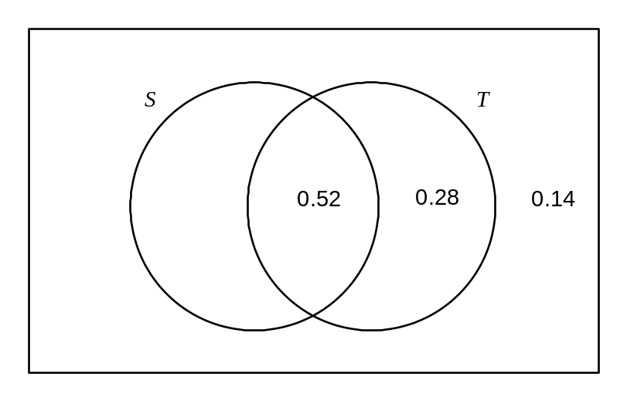
(a) Determine

(i) 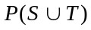. (1 mark)
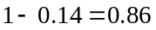

(ii) 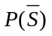. (1 mark)
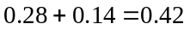

(iii) 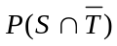 (1 mark)
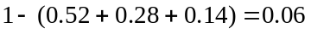

(iv) 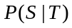 (2 marks)
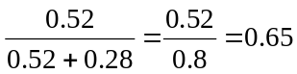

(b) If 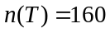, determine 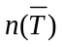. (2 marks)
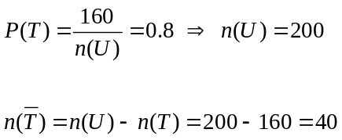

Question 8 (8 marks)
The current income tax rates that apply to individuals who are Australian residents are shown in the table below.

Annual taxable income | Tax on this income
0 - $18 200 | Nil
$18 201 - $37 000 | 19c for each $1 over $18 200
$37 001 - $80 000 | $3572 plus 32.5c for each $1 over $37 000
$80 001 - $180 000 | $17547 plus 37c for each $1 over $80 000
$180 001 and over | $54547 plus 45c for each $1 over $180 000

The sole owner of a company that has made an annual profit of $138 500 is considering three options to minimise their tax payable.

Option A: Pay the whole profit of $138 500 to themself and have it treated as their annual
taxable income.

(a) Determine the tax on Option A. (3 marks)
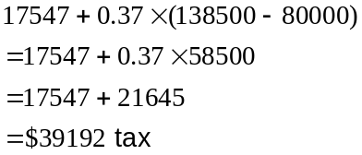

Option B: Pay company tax of 30% on the whole profit.

(b) Determine the tax on Option B. (1 mark)
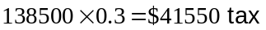

Option C: Pay themself $37 000 to be treated as annual taxable income and pay company tax
of 30% on the remainder of the profit.

(c) Determine the tax on Option C. (3 marks)
Annual taxable income on $37 000:
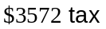

Company tax:
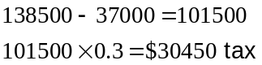

Total tax 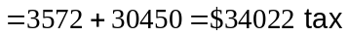

(d) Which option minimises the tax payable? (1 mark)
Option C

Question 9 (7 marks)
The straight line with equation 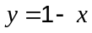 is shown below.
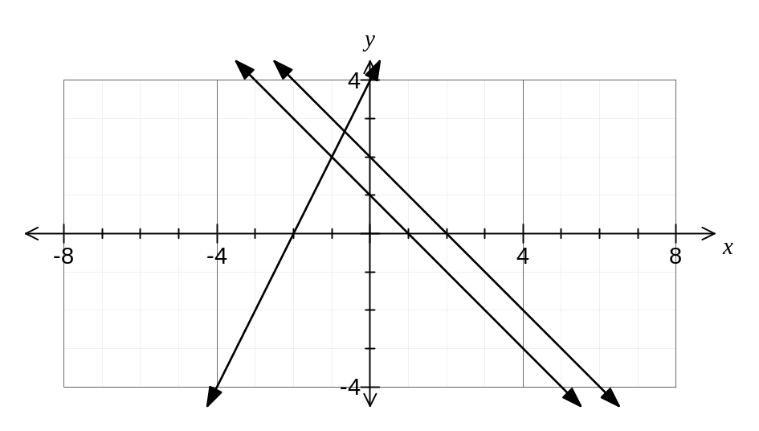

(a) Is the line with equation 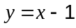 perpendicular to the line ? Justify your answer.
(1 mark)
Yes. The gradients of the lines are 1 and -1, which multiply to make -1.

(b) On the axes above, draw the straight line parallel to that has a -intercept of 2.
(2 marks)

(c) State the equation of the straight line parallel to that has a -intercept of 2.
(1 mark)
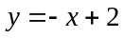

(d) On the axes above, draw the straight line through (-3, -2) that has a gradient of 2.
(2 marks)

(e) State the equation of the straight line through (-3, -2) that has a gradient of 2. (1 mark)
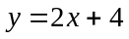

Question 10 (13 marks)
The dot frequency graph below shows the scores achieved by 60 students in a test with a maximum score of 25.

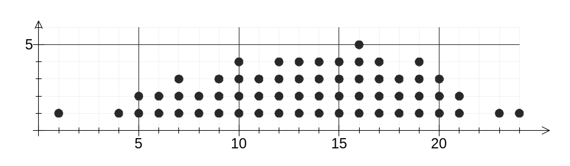

(a) For these scores, state the

(i) mode (1 mark)
16

(ii) range (1 mark)
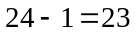

(b) The median of 60 scores is the mean of the 30th and 31st scores, when arranged in ascending order. Determine the median score for this group of students. (1 mark)

14

(c) Complete the grouped frequency table below for the scores. (3 marks)

Score | Frequency
1 - 4 | 2
5 - 8 | 9
9 - 12 | 14
13 - 16 | 17
17 - 20 | 14
21 - 24 | 4

(d) For the frequency table in (c) state

(i) the midpoint of the 5 - 8 class interval (1 mark)
6.5

(ii) the class boundaries of the 5 - 8 class interval (1 mark)
4.5 and 8.5

(d) Use the data in the grouped frequency table to calculate the mean score. (2 marks)

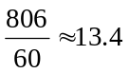

(e) Construct a frequency histogram for the grouped data. (3 marks)

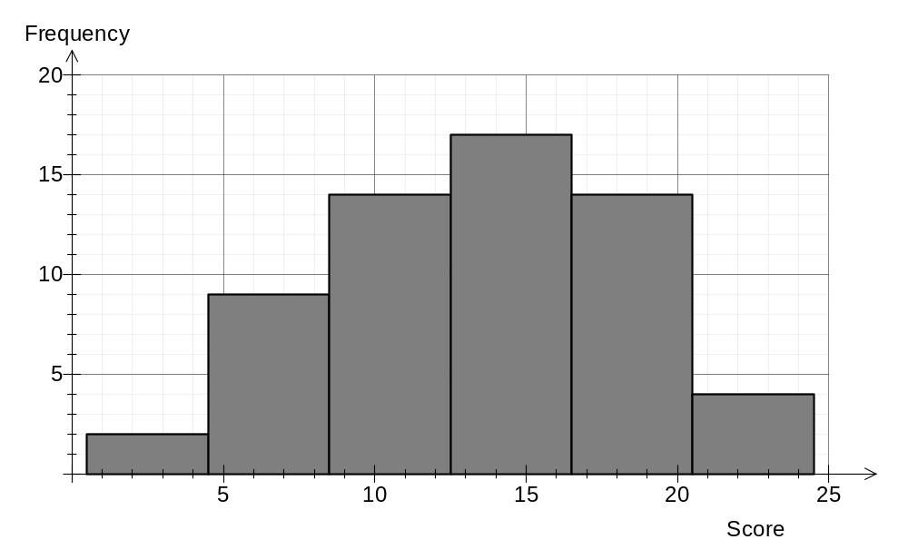

Question 11 (10 marks)
The two-way table below shows the numbers of students in a school who have a part-time job, with students classified by year group and gender.

 | Girls |  |  | Boys
 | Yr 10 | Yr 11 | Yr 12 | Yr 10 | Yr 11 | Yr 12 | Total
Part-time job | 12 | 23 | 22 | 14 | 27 | 31 | 129
No job | 46 | 32 | 27 | 50 | 32 | 21 | 208
Total | 58 | 55 | 49 | 64 | 59 | 52 | 337

(a) Complete the six missing entries in the table. (3 marks)

(b) How many of the students are

(i) in Year 11 and have a part-time job? (1 mark)

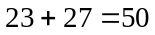

(ii) in Year 10 or have no job? (2 marks)
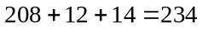

(c) If one of the students is selected at random, what is the probability that the student

(i) is a Year 12 girl with no job? (1 mark)

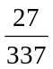

(ii) is not in Year 11 and has a part-time job? (1 mark)

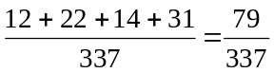

(iii) has a part-time job, given that they are in Year 10? (2 marks)

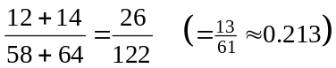

Question 12 (6 marks)
The table below shows the final marks for three students in the practical and theory parts of their course.

Student | Andi | Beau | Charlie
Practical mark (%) | 56 | 67 | 51
Theory mark (%) | 65 | 56 | 68

(a) Calculate the overall percentage mark for each student if the practical and theory marks have equal weighting, and hence rank the three students in order from highest to lowest overall mark. (3 marks)

Andi: 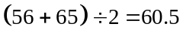
Beau: 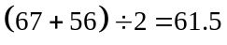
Charlie: 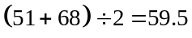

Order: Beau, Andi, Charlie

(b) Calculate the overall percentage mark for each student if the theory mark is weighted three times that of the practical mark, and hence rank the three students in order from highest to lowest overall mark. (3 marks)
Andi: 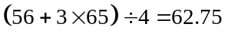
Beau: 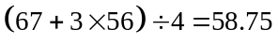
Charlie: 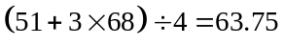

Order: Charlie, Andi, Beau

Question 13 (10 marks)
The numbers on the network below show the maximum possible flow, in kL per minute, along each of the 13 drainage channels connecting the source at A to the sink at H.

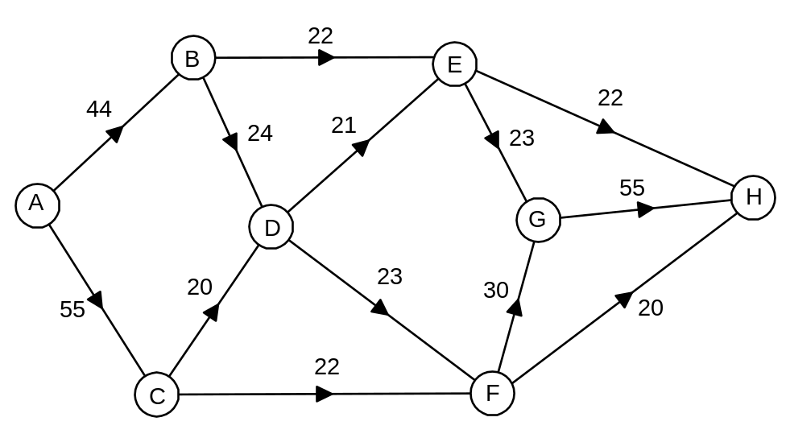

(a) Explain why the drainage channel from A to C could not be used to its full capacity.
(1 mark)
A maximum of 42 kL/min can flow out of C, which means the full capacity of 55 kL/min from A to C will never be utilised.

(b) Determine the maximum flow, in kL per hour, that is possible through this network from the source to the sink. Show systematic working to allow your solution to be checked.
(4 marks)
ABEH 22
ABDEGH 21
ABDFGH 1
ACDFGH 20
ACFGH 9
ACFH 13
Total 86 kL/min

(c) Engineers expect a total of 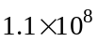 litres of stormwater to arrive at the source over the next 24 hours. Is the drainage system capable of clearing this volume of water in 24 hours? Justify your answer. (3 marks)

Yes. In 24 hours the system can drain

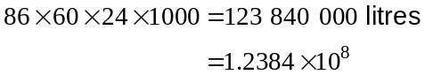

which exceeds litres.

(d) What effect, if any, would there be on the maximum flow through the network each minute if the capacity of the drainage channel from A to C was reduced by 20 kL per hour? Justify your answer. (2 marks)

Reduce by 7 kL per minute.

AC has spare capacity of 13 kL, but the remaining 7 kL cannot be redirected as AB has no spare capacity and so will be lost.

Question 14 (7 marks)
The graphs of 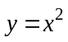 and 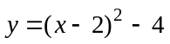 are shown below.

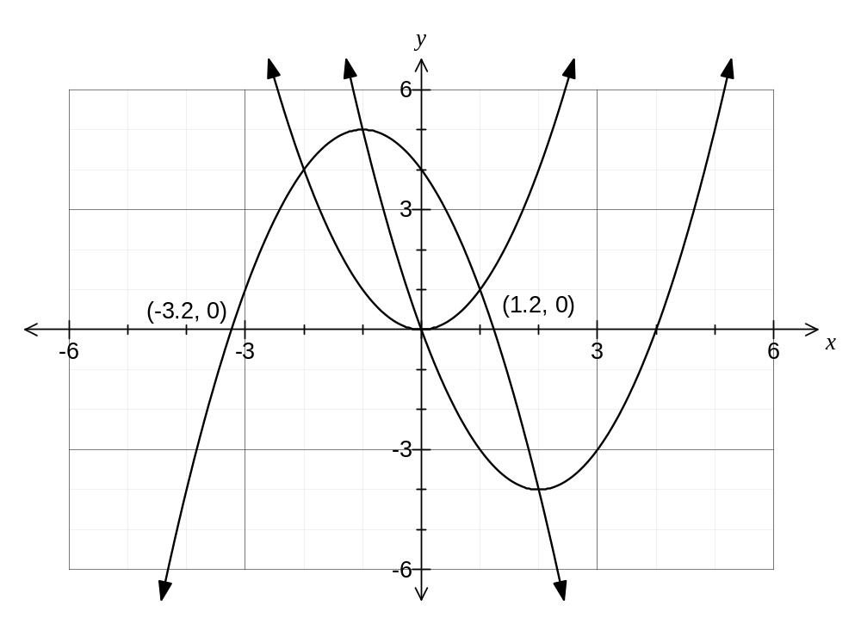

(a) On the same axes, sketch the graph of 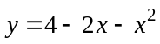, clearly labelling the coordinates of the -intercepts to one decimal place. (3 marks)

(b) Using the graph, or classpad, solve

(i) 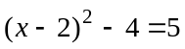 (2 marks)
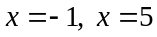

(ii) 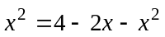 (2 marks)
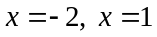

Question 15 (7 marks)
A school has marked out a Cartesian coordinate grid on a level playground so that one unit measures exactly one metre. A copy of the grid is shown below.
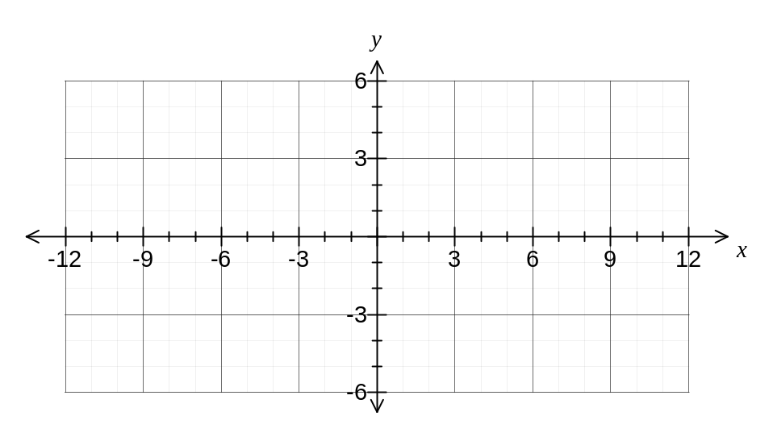
(a) A teacher is standing at the point with coordinates (-5, 2) and an assistant is standing at the point with coordinates (7, -3).

Calculate the distance between the teacher and the assistant. (2 marks)
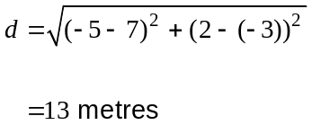

(b) A student starts at the point (-1.5, 6) and walks in a straight line to the point (3.5, -4).

Determine the equation of the straight line this student walked along. (2 marks)

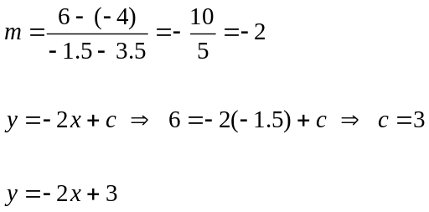

(c) Another student started at the point (-7, -5) and walked along a path parallel to the line with equation 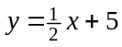 until they reached the -axis.

Determine how far this student walked, giving your answer to one decimal place.
(3 marks)
Intersect -axis at (3, 0)

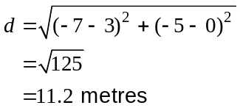

Question 16 (8 marks)
The numbers on the arcs of the network below represent the time, in minutes, to travel directly between various nodes of the network.

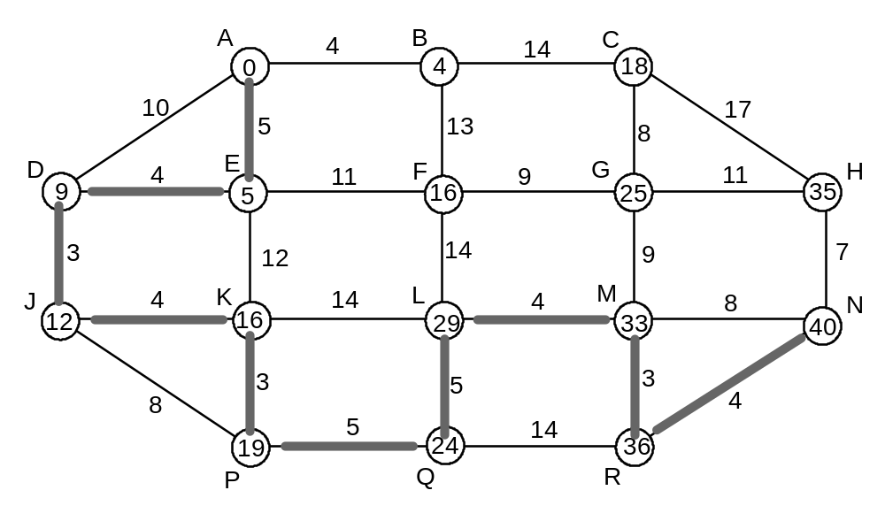

(a) Determine the shortest time to travel from C to R. (1 mark)

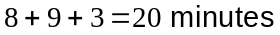

(b) Determine the quickest route to travel from A to N and state the time taken. To obtain full marks, numbers must be added to the above network to show that an appropriate method has been used and the route highlighted. (5 marks)
A - E - D - J - K - P - Q - L - M - R - N

Time is 40 minutes

(c) What change, if any, would be made to your answer to (b) if the time to travel between P and Q was reduced from 5 minutes to 1 minute? (2 marks)
No change to route.

Time would reduce by 4 minutes to 36 minutes.

Question 17 (8 marks)
An initial amount of $1000 is deposited with a savings bank offering an interest rate of 0.4% per month, compounded monthly.

(a)

(i) What is the value of the investment after one year, to the nearest cent? (3 marks)

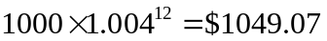

(iii) How much interest has accumulated over the first year? (1 mark)

$49.07

(b) Consider an amount of $3450 is deposited with a savings bank offering an interest rate of 0.25% per month, compounded montly.

(i) What is the annual interest rate as a percentage? (2 marks)

3%

(ii) How much interest in dollars would accumulate over the first year of this investment?
(2 marks)

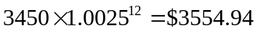
Question 18 (9 marks)
The following data, collected several years ago, shows the location of the homes of Australians together with the age distribution of the Indigenous population.

Location | Major cities | Inner regional | Outer regional | Remote | Very remote
Total population | 12 509 088 | 3 895 715 | 2 008 429 | 342 211 | 204 028
Total Indigenous population | 126 144 | 83 004 | 94 602 | 35 025 | 71 864
Percentage age distribution of the Indigenous population (years)
0 - 14 | 39 | 42 | 40 | 37 | 36
15 - 24 | 19 | 18 | 17 | 17 | 19
25 - 44 | 29 | 26 | 28 | 30 | 29
45 - 64 | 11 | 11 | 12 | 13 | 12
65+ | 2 | 3 | 3 | 3 | 4
Total | 100 | 100 | 100 | 100 | 100

(a) What percentage of the Indigenous population who lived in a location classified as very remote were aged under 15? (1 mark)

36%

(b) Determine the percentage of the total population living in a location classified as inner regional that was non-Indigenous. (2 marks)

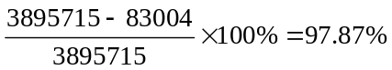

(c) Show that approximately 36 600 Indigenous people aged 25 - 44 lived in major cities.
(2 marks)
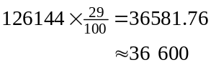

(d) What percentage of Indigenous people who lived in a location classified as outer regional were aged 25 or over? (1 mark)
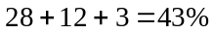

(e) How many Indigenous people aged less than 25 lived in a location classified as either remote or very remote? Give your answer to the nearest hundred people. (3 marks)

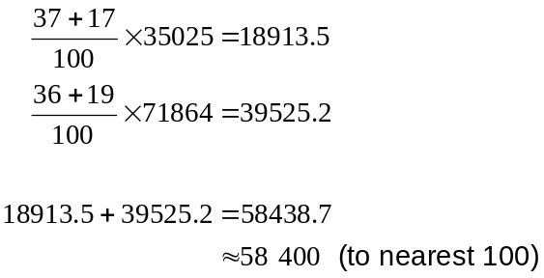

Additional working space

Question number: _________

Additional working space

Question number: _________

This examination paper may be freely copied, or communicated on an intranet, for non-commercial purposes within educational institutes that have purchased the paper from WA Examination Papers provided that WA Examination Papers is acknowledged as the copyright owner. Teachers within Rossmoyne Senior High School may change the paper provided that WA Examination Paper's moral rights are not infringed.

Copying or communication for any other purposes can only be done within the terms of the Copyright Act or with prior written permission of WA Examination papers.

Published by WA Examination Papers
PO Box 445 Claremont WA 6910

